**OlympiData – User Manual**

Table of Contents

About our application 2

Administrator username and password 2

Application screens 2

The application main screen: 2

The quiz page: 3

Adding a question page: 3

Admin page: 4

Performing DB update via the web UI 4

# About our application

Our web application – OlympiData – is a social trivia game for the Olympic games, inspired by the upcoming Olympics. It retrieves Olympics data from DBpedia and enables the users to play and add new questions.

Our website homepage directs the user to the two major parts of the website:

1. Olympics trivia game – the user will be given 10 different questions about the Olympics, and will be scored with 10 points for each correct answer. After each answer is submitted the user is notified if he/she is correct and get to see more info about the correct answer (if info is available). The user is also provided with info about the percentage of users who answered the question correctly.
2. Adding a question to the question pool – in this section the user can add a question to the questions pool of our game. There are 6 question formats, and the user can fill the missing parameters for the specific question and submit it.

The website also consists of an admin page, where the user can run the database update script in order to get updated info from DBPedia and view the results of the update script run.

In any case of error (e.g. running queries on the DB), the application will notify the user.

# Administrator username and password

In order to access the admin page, a user name and password should be entered:

Username: DbMysql08

Password: 12345

# Application screens

## The application main screen:

URL: <http://www.cs.tau.ac.il/~naftaly1/DB_project/SRC/APPLICAITON-SOURCE-CODE/>

Here the user can choose whether to start a new trivia game, or to add questions to the question pool.



## The quiz page:

This page can be accessed by clicking on 'Start the quiz button' of the main screen.

Here the user can:

* Answer the questions

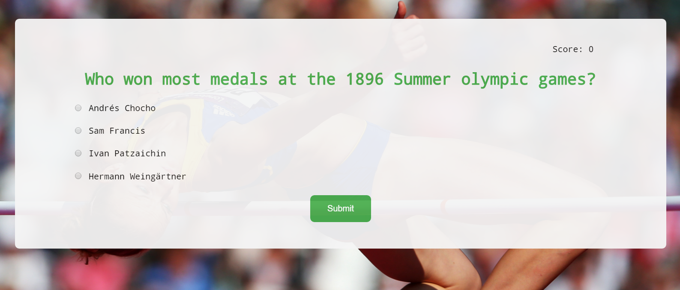

* Get feedback on every question and view how many people were correct in the past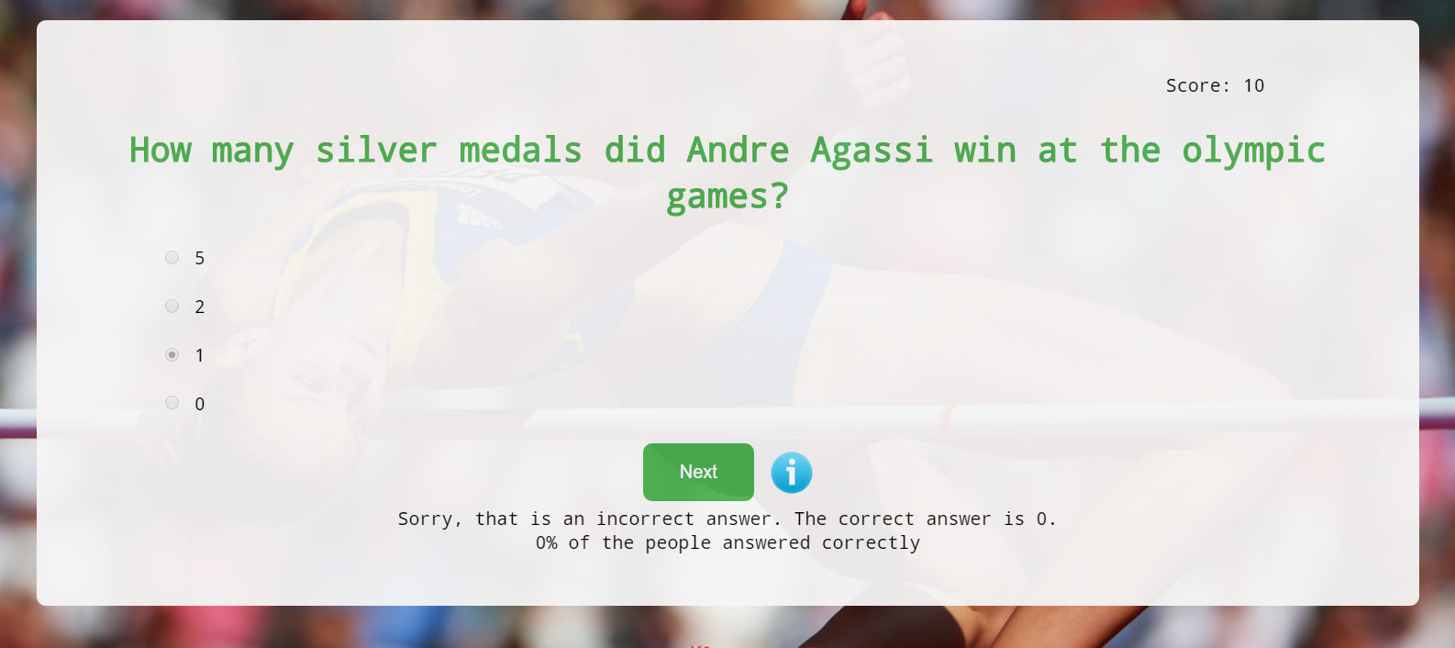
* Get to see the info about the correct answer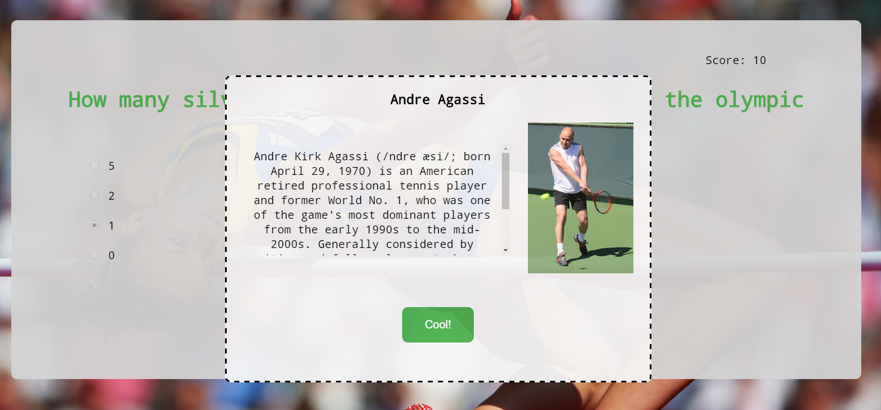

## Adding a question page:

This page can be accessed by clicking on 'Add a question' button of the main screen.

Here the user can:

* Choose the type of questions he/she wishes to add

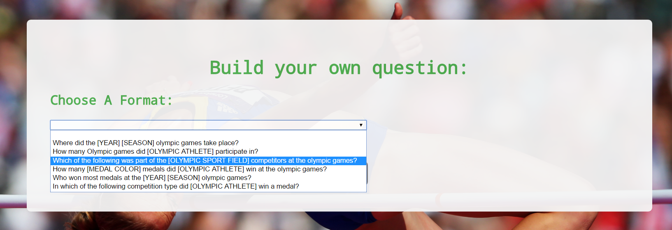

* Choose the parameter for the specified question

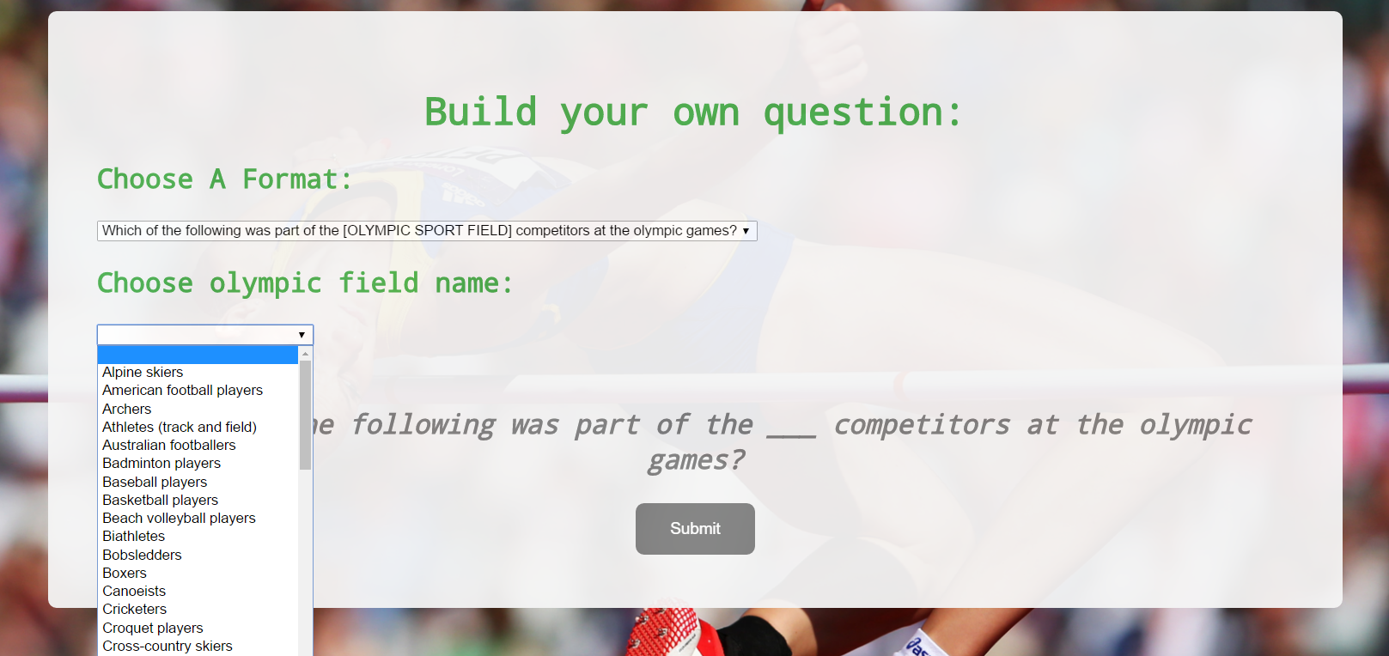

* Submit the question and choose whether to submit another one, or go back to main screen

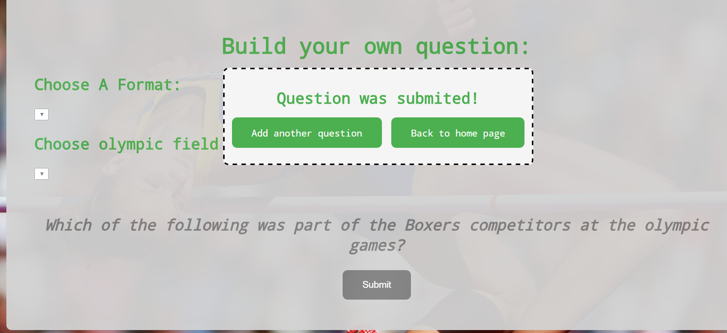

## Admin page:

URL: <http://www.cs.tau.ac.il/~naftaly1/DB_project/SRC/APPLICAITON-SOURCE-CODE/admin/>

Here the user can click on the update button in order to update the DB with data from DBPedia. Once the script finished running, the log of the script run will be printed on the page.

# Performing DB update via the web UI

1. Go to the admin page:

<http://www.cs.tau.ac.il/~naftaly1/DB_project/SRC/APPLICAITON-SOURCE-CODE/admin/>

1. Enter user and password as mentioned above.
2. Click on the update button.
3. Wait for the script log run to appear (this takes ~20-30 minutes on a successful run).